**Complied Design Documentation (U-Gallery)**

User Story

* As a user I need to view all images in a selected local folder then I can select what I want to see.
* As a user I want to auto play the photo gallery in large scale, then I can see clearly.
* As a user I want to zoom selected image then I can decide, whether it is suitable to enlarge or not.
* As a user I want to find all the available EXIF data of the image then I can find the place where the photo is taken.
* As a user I need to get photo with webcam and save it.
* As a user I want to find the current geo-location when the photo is taken.
* As a user I want to share newly taken photo with geo tag then anybody can find where I am.

User Case



**User**

**Wireframes**

**App tile UI**

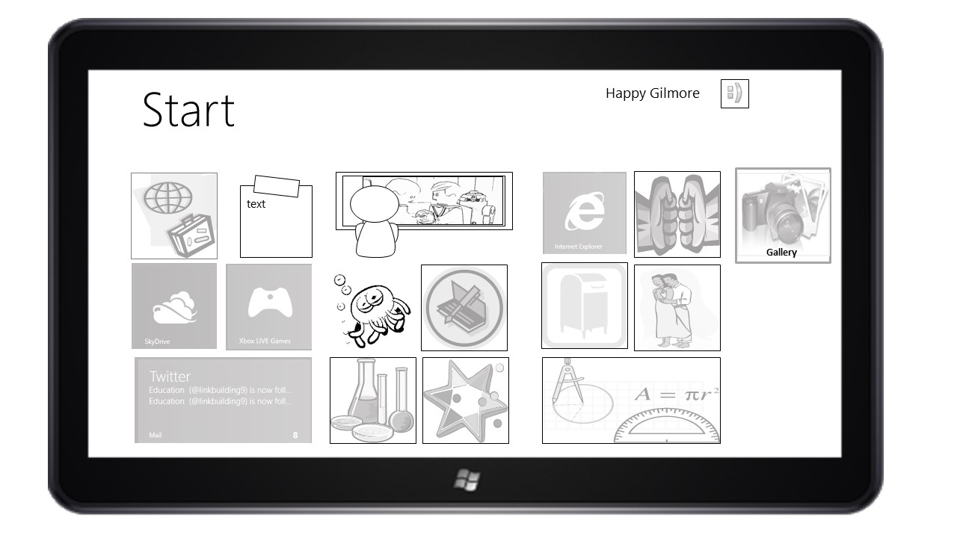

**Start-up UI**

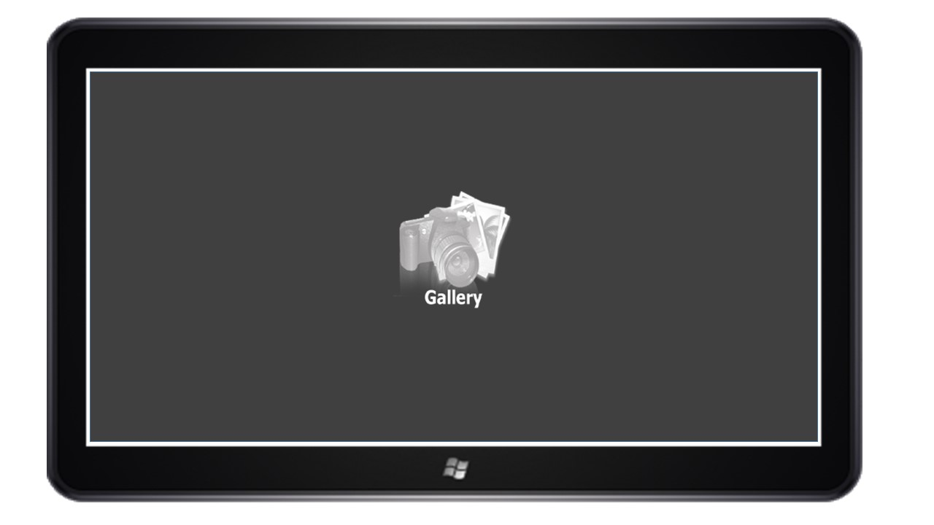

**Main Gallery UI**

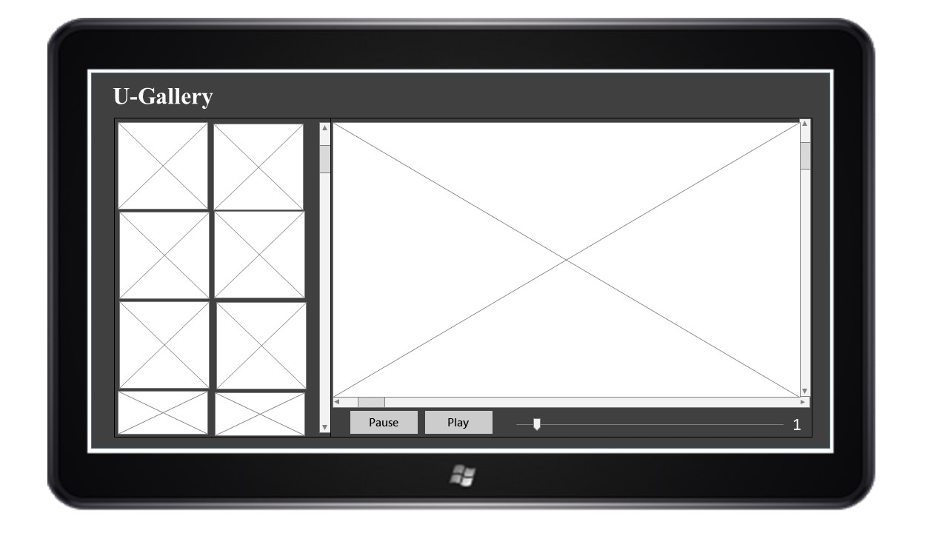

**Details UI**

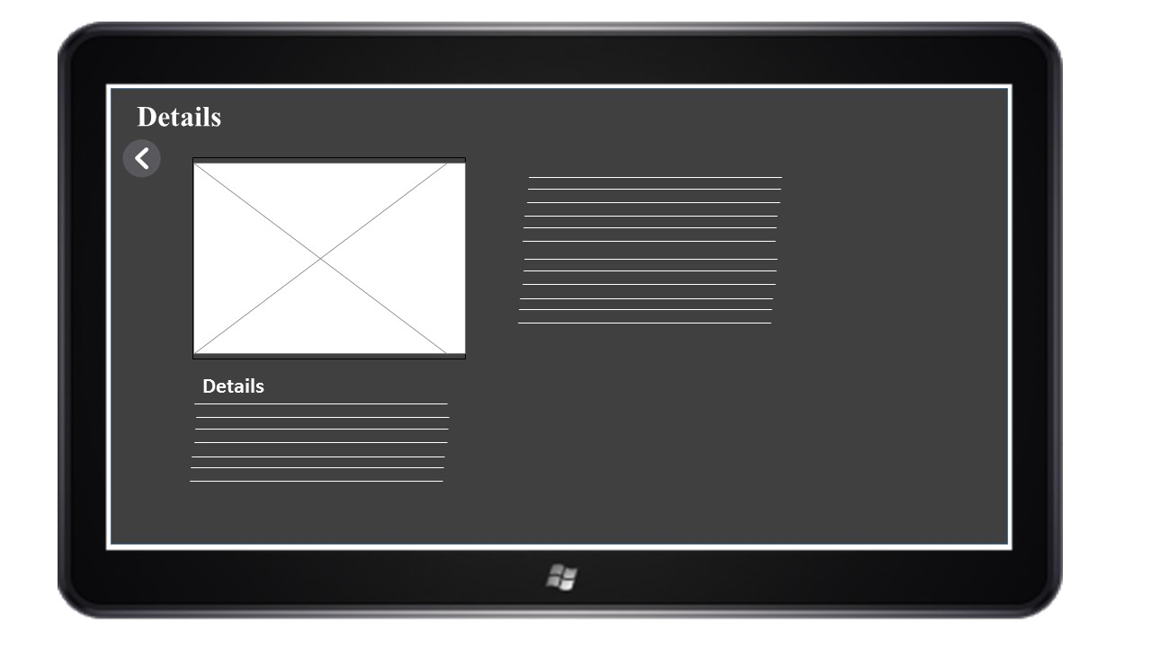

**Appbar UI**

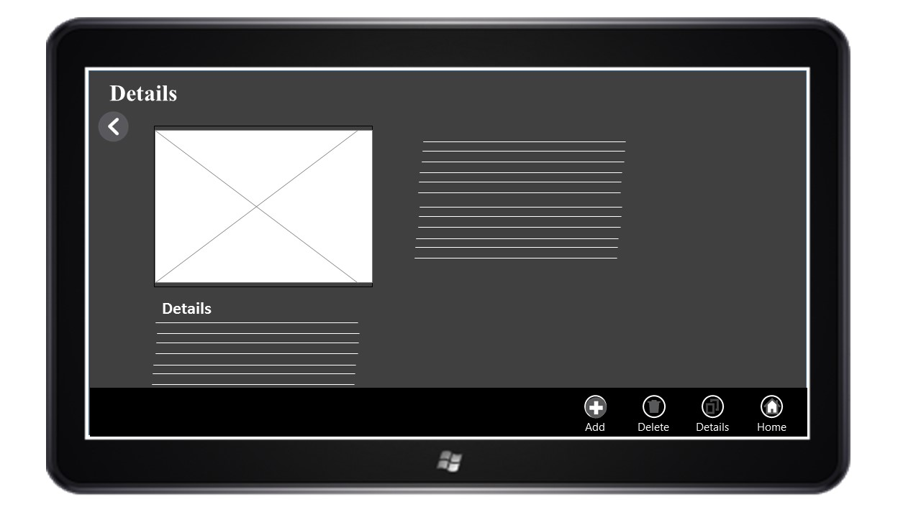

**Add me empty UI**

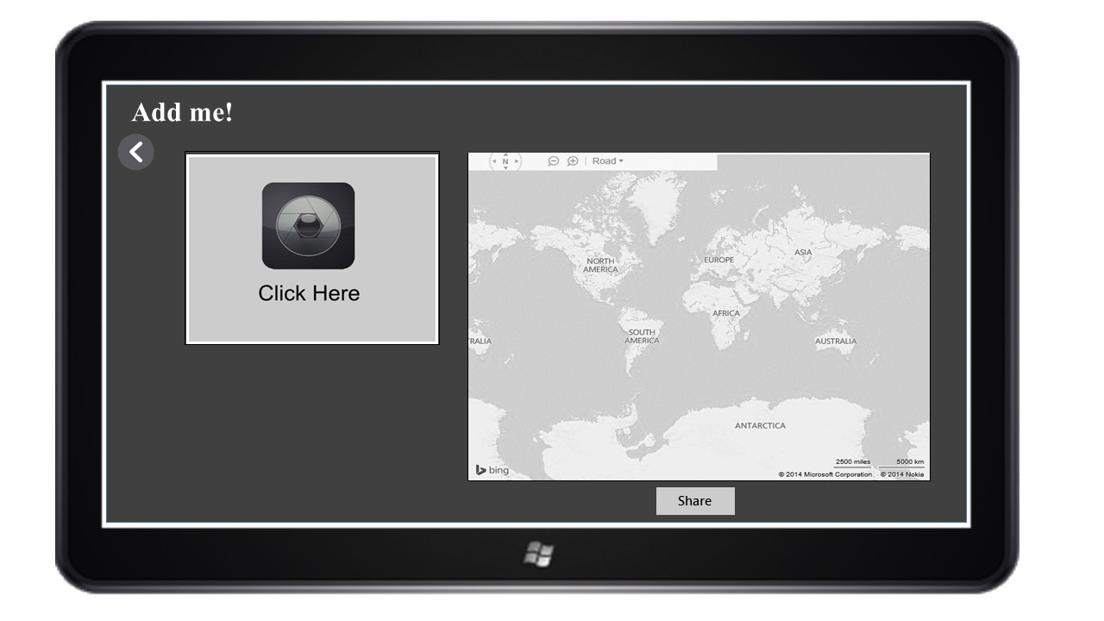

**Add me active UI**

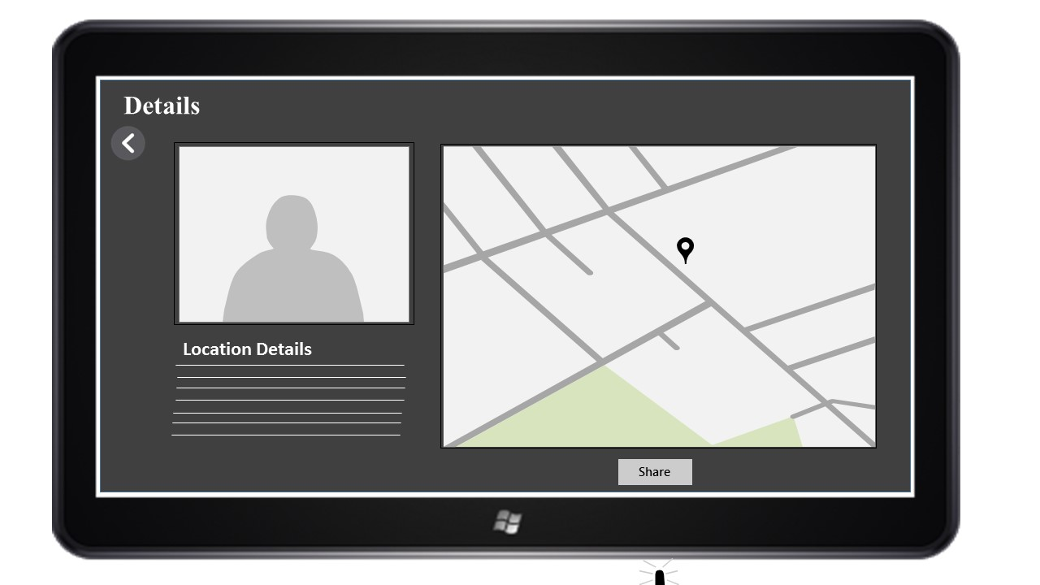

**Share UI**

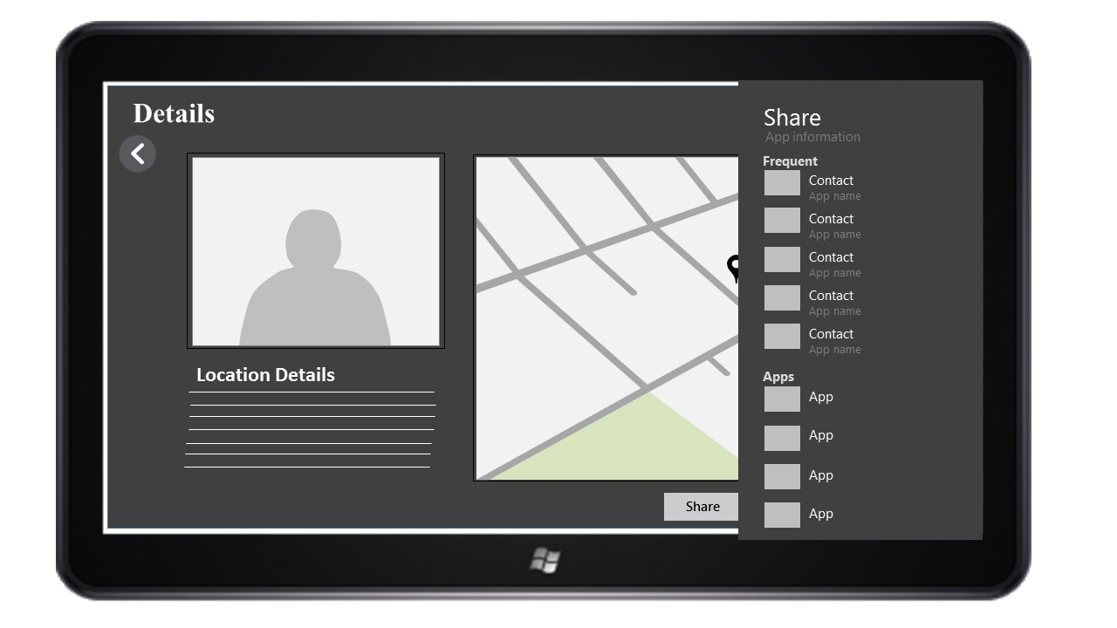

**User Testing**

|  |  |  |
| --- | --- | --- |
| Testing Description | Expected Result | Actual Result |
| Display selected folder photos | Can view all the photos in the selected folder | Can view all the photos in the selected folder |
| Image auto play | Auto play all the images | Auto play all the images |
| Enlarge image | Show selected image in large scale. | Show selected image in large scale. |
| Play and Pause | Click play button   * Auto play starts   Click pause button   * Auto paly stops | Click play button   * Auto play starts   Click pause button   * Auto paly stops |
| Zoom | Zoom in and zoom out when range bar move left and right. | Zoom in and zoom out when range bar move left and right. |
| Details | Display all the image property. (EXIF data) | Only displays image size and file location. |
| Use Webcam | Can take a photo with the webcam, display and save | Can take a photo with the webcam, display and save |
| Geo-Location | Displays the geo-location  (Longitude and latitude) | Displays the geo-location  (Longitude and latitude) |
| Map | Displays current geo-location on the map | Displays current geo-location on the map |

**To-do List**

* Get all the EXIF data.
* Get current location’s address.